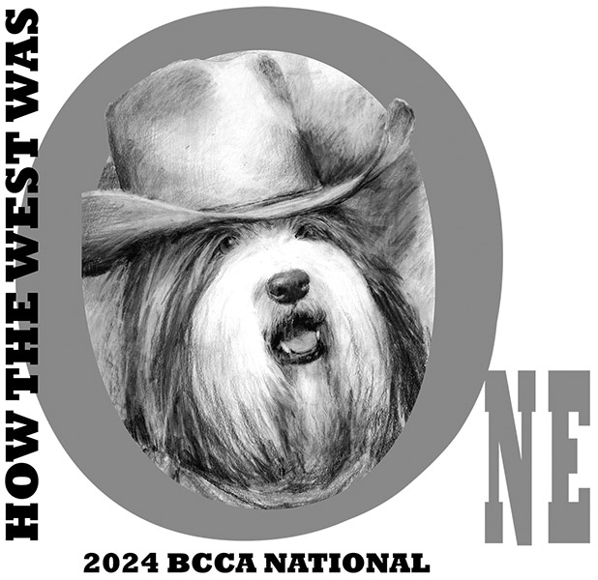

**2024 National Specialty Trophy Fund Request**

**16 June 2024**

Whether you’re planning to attend the BCCA National Specialty in Santa Rosa, CA this fall or not, you can still play an important part in the coming Nationals. Just visit the trophy sponsorship table on the 2024 Nationals website, and choose the award or awards you would like to sponsor. If you wish, you may make this donation in memory of a departed Beardie, friend, or family member. Simply fill in below the award or awards you wish to sponsor and complete the dedication section. We hope you will also consider a donation to the general trophy fund. You have until August 1, 2024 for your sponsorships to appear in the catalog.

Award Donation Dedication

_______________________________________________________________________________________________________

_______________________________________________________________________________________________________

Donation for General Trophy Fund _____ ____________________________________________________

Total: _____

**Please make your check payable to “2024 BCCA National Specialty” and send it with a copy of this form to:**

**Joanne Williamson, 13 Horne Homestead Rd, Charlton, MA 01507**

**OR check here _______ if you would prefer to receive a PayPal invoice.**

Sincerely,

_______________________________________________________________________________________________________

Joanne Williamson Phone: 978-339-3373 E-mail: [balgrae@ix.netcom.com](mailto:balgrae@ix.netcom.com)